Integration testing

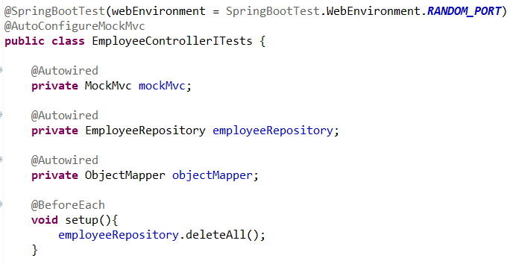

given() is not required in integration testing

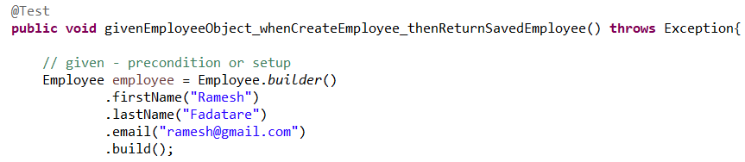

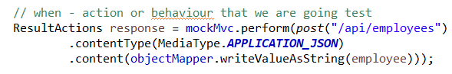

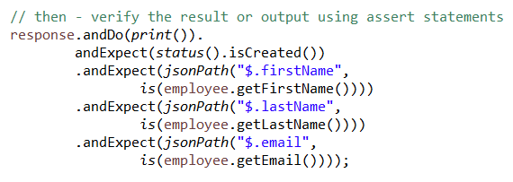

For get all employees

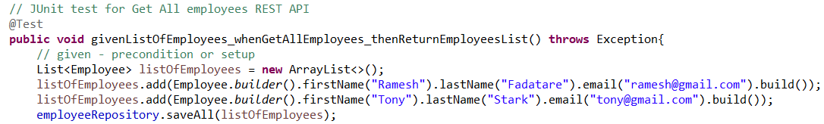



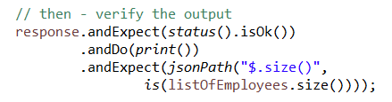

Get emp by id positive scenario

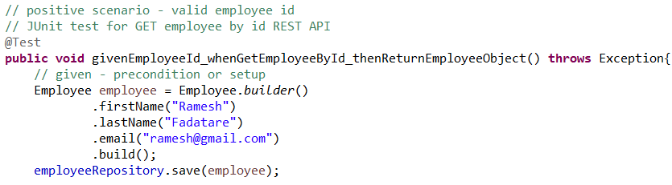



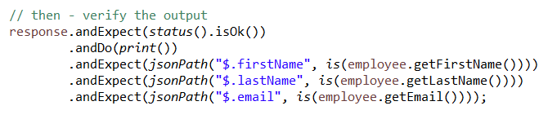

Get emp by id neg scenario

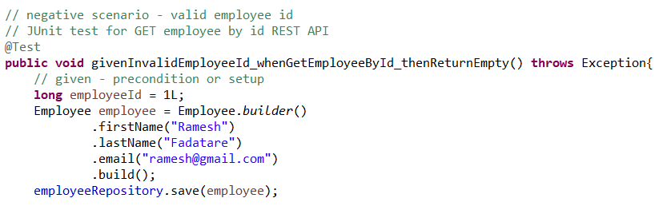



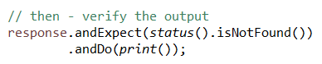

Delete emp

